**Stock Market Timing Prediction Expert System**

**Version 1.0**

**Prepared by :-**

**Group No. 8**

**INDIAN INSTITUTE OF INFORMATION TECHNOLOGY**

**Table of Contents**

1. **Abstract 3**
2. **Introduction 4**
3. **Theoretical Basis and Literature Review 5**
   1. Problem Definition 5
   2. Related Research to solve the problem 5
   3. Literature review 5
4. **Similar Exporter System Models 6**
   1. Methods for Stock Movement Prediction 6
   2. JST Based method 6
5. **Novelty of work and Contribution 6**
6. **Background/ Materials and Methods 7**
   1. General Overview 7
      1. Real Time Expert System 7
      2. Knowledge representation 7
      3. Inference Engine 8
   2. Dataset 8
7. **Tools and Techniques 9**
   1. Environmental Setup 9
      1. Java Version and Libraries used 9
   2. Use Case Diagram 10
   3. FlowChart Diagram 11
   4. Implemented Modules 11
      1. Candlestick Chart 11
8. **Proposed Model and Framework 12**
   1. Proposed Model 12
   2. Features of the Model 13
9. **Result 14**
10. **Conclusion 15**
11. **References 16**

**1.Abstract**

The prediction of a stock market may fill in as an early suggestion framework for short-term investors and as an early budgetary trouble cautioning framework for long haul investors. Forecasting exactness is the most significant factor in choosing any determining strategies. Research efforts in improving the accuracy of Forecasting models are expanding since the last decade. The stock determinations those are appropriate for investment is a troublesome task. The key factor for each investor is to win greatest benefits on their ventures.

In the previous decades, there is an expanding enthusiasm for predicting markets among financial analysts, policymakers, scholastics and market creators. The goal of the proposed work is to improve the managed learning calculations to anticipate the stock cost.

We have developed a solution to this problem by making an expert system based project, that uses its knowledge base and inferencing techniques to predict the best time to invest in Stocks with minimum inputs so as to guarantee a user friendly framework.

**2. Introduction**

Investors are very familiar with the saying, "buy low, sell high" however this doesn't give enough context to settle on legitimate venture choices. Before a financial specialist puts resources into any stock, he should know how the securities exchange carries on. Putting resources into a decent stock however at an awful time can have awful outcomes, while interest in an unremarkable stock at the correct time can endure benefits. Financial investors of today are confronting this issue of trading as they don't appropriately comprehend with respect to which stocks to purchase or which stocks to sell so as to get ideal benefits. Foreseeing long haul estimation of the stock is moderately simpler than anticipating on day to ­day premise as the stocks fluctuate quickly consistently dependent on world occasions.

There are two significant flows of thought in the capital market. One of them depends on the fundamentalist examination (FA) that emerges from premises about the prudent monetary basics of associations,including their business structures, balances, money related wellbeing, among other criteria. The other one depends on specialized examination (TA), otherwise called realistic investigation, and it emerges from the conviction that:

(I) all data that is important for the choice of a given resource is as of now remembered for its value,

(ii) the value contains data that has not been utilized in the value's count,

(iii) history repeats itself, and

(iv) costs move as indicated by a pattern.

The subsequent current profits itself copiously of realistic portrayals used to speak to a resource's conduct and help financial specialists' choices. These two flows of thought are not commonly barring, and the two of them may give synchronous help to one same financial specialist in his procedure of choice.

**3.Theoretical Basis and Literature Review**

**Problem Definition:**

Securities exchange pulls in a huge number of speculators' souls from all around the globe. The hazard and benefit of it have incredible appeal and each speculator needs to book benefit from that. Individuals utilize different techniques to anticipate showcase instability, such as K-line chart investigation strategy, Point Data Diagram, Moving Average Convergence Divergence, even coin hurling, fortune-telling, thus on. Now, all the money related information is put away carefully and is effectively available. Accessibility of this immense measure of money related information in advanced media makes proper conditions for information mining research. The significant issue here is to utilize the accessible information.

**Related Research to Solve the Problem:**

As of late, a great deal of fascinating work has been done in the region of applying Machine Learning Algorithms for breaking down value designs and foreseeing stock cost. Most stock brokers these days rely upon Intelligent Trading Systems which help them in foreseeing costs dependent on different circumstances and conditions. Recent inquires about utilizes input information from different sources and various structures. A few frameworks utilize authentic stock information, some utilization money-related news stories, some utilization master surveys while some utilization a half and half framework which takes different contributions to anticipate the market. Also, a wide scope of AI calculations are accessible that can be utilized to plan the framework. These frameworks have various ways to deal with taking care of the issue. A few frameworks perform the scientific examination on notable information for forecast while some perform assessment investigation on budgetary news articles and master audits for prediction. However, as a result of the unpredictability of the financial exchange, no framework has an ideal or exact expectation.

**Literature Review**

Predicting Stock Prices Using Technical Analysis and Machine Learning, by Jan Ivar Larsen, Norwegian Institute of Science and Technology

Authentic stock costs are utilized to anticipate the future stock costs. The developed stock value expectation model uses a novel two-layer approach that employs space information from specialized investigation in the principal layer of thinking to idea second layer of thinking dependent on AI. The model is enhanced by a money the executives procedure that utilization the verifiable achievement of expectations made by the model to decide the measure of funding to contribute on future forecasts.

The outcomes reported in the paper show that the created prediction model utilizing space information, AI and a cash the board system can create significant benefits when assessed on the Oslo Stock Exchange. Although the model is less beneficial when assessed from January 2008, we do find that it does perform shockingly well considering the worldwide money related emergency that occurred in mid-2008. In numerous reproductions the model has recovered the misfortune brought about by the monetary emergency by mid-2009 and begins creating benefits by late-2009, a noteworthy outcome considering that the benchmark file fell by around 300 from mid-2008 to 2009. The exclusion of exchange costs in the portfolio recreation system is maybe the most obvious blemish in the outcomes recorded in the past part. Transaction costs can be hard to display as they rely upon the dealer utilized, the request aggregate of the executed exchange, charge reasonings, and different viewpoints. In the conclusive outcomes, we utilized as exchange limit which would diminish the impacts on exchange costs on the outcomes. A more thorough statistical investigation of the forecasts created by the distinctive model modules would have been gainful in approving the outcomes. In any case, because of time limitations this was not finished in time and will therefore be included as a point for future work.The most obvious issue with the expectation model is the characteristic stochasticity in the model.

Thus, we close this end by sketching out some potential focuses for future work that might be utilized to relieve this test and increment trust in the model.One way to deal with moderate the evident hazard and make increasingly stable outcome might be to extend the Feature Generation module with extra space information. As the current system utilizes verifiable costs as its sole reason for expectations, it appears to be normal to expand the system with specialists that performs key examination. Moreover, the worldwide economy and financial exchanges impacts each other in numerous ways,which may propel an operator that screens securities exchanges in different pieces of the world. For the hazard disinclined broker the model may appear to be excessively shaky in its present state. However, we still esteem the outcomes agreeable, more so than what was normal when the work was started, both as far as the model design and the reported outcomes.

**4. Similar Expert System Model**

**Methods for Stock Movement Prediction:**

In our technique, just verifiable costs are utilized to anticipate the stock development. The reason for this strategy is to examine whether there are designs throughout the entire existence of the stock or not. Likewise, this model was utilized as a standard to assess whether reconciliation of the feelings is compelling by contrasting and other conclusion models.

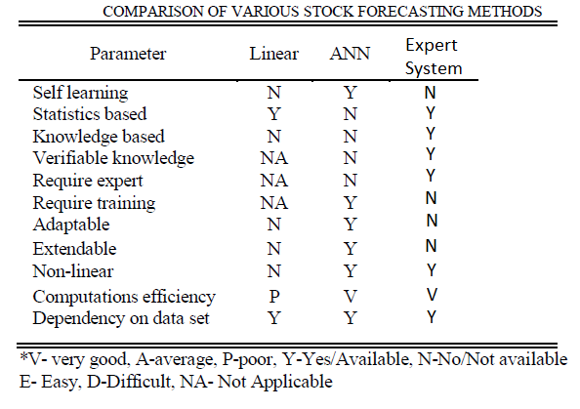

**JST based method:**

The assessment is regularly communicated on a point or perspective. At the point when individuals post the message on the online networking to express their assessment for a given stock, they will in general talk their conclusions for a specific theme, for example, benefit and profit. In view of sets of point conclusion, they would believe that the future cost of that stock goes up or down. From that instinct, we propose another element theme opinion for the stock prediction model. To extricate sets of point slant, we attempted to utilize two sorts of models.

**5. Novelty of work and contributions**

The examination helps a great deal of new financial specialists in choosing when to purchase or sell a specific stock. It likewise helps in understanding the feelings of experienced monetary experts and money related news information more rapidly than doing likewise physically.The project finds the pattern for the given data and seeks possible future trends.

**6. Background / Materials and Methods**

**General overview**

**Real time expert system:**

Real time expert systems are a kind of special systems which have a special properties and serves a unique purpose. This kind of system can solve specific problems whose knowledge base are already developed. Real time expert system has to respond for any specific input in a finite amount of time.

For stock market prediction system, it has to suggest whether to buy or sell the stock very quickly, so that the loss could be minimised and maximum profit is achieved. Users should be able to get the best buying and selling options of the stock at the particular time. Huge loss can be unsatisfactory for an organization or an individual, so our expert system should give accurate results within specified deadline.

Expert System comprises of three principle parts : knowledge base, facts and an inference engine.

**Knowledge Representation:**

The knowledge base is the core of a specialist framework. It contains the information aggregated in a lot of rules and facts. Significant stock knowledge and their patterns is represented by the rules which is very helpful in stock market prediction.

A real time knowledge based system continuously acquires data from the stock markets and generates patterns from the data and updates the knowledge base. The knowledge base is created using the rules and patterns. Then candlestick chart is prepared using these patterns which is used for predicting best stock market timing. It is important to decide when to purchase or sell stocks so as to get exceptional yields from stock market. We have developed a candlestick chart analysis expert system for anticipating the stock market timing. The expert system has patterns and rules which can foresee future stock value deviations.

Stock market data is as follows:

* Day by day data of the stock market.
* Data patterns.
* Everyday records containing patterns with their width and height.
* Candlestick chart.
* Data structure such as table which contains all the transactions made by individuals regarding the gain or loss.

**Inference Engine:**

Inference engine is a significant segment of framework which is used to solve the stock related problem or depict how to arrive at the specific objectives.

The inference engine of an expert system is made out of a matching algorithm. The match algorithm is responsible to identify the rules that are matched by the facts in database so it can be considered as an important part of an expert system.

Inference engine portrays which rules to be applied on a specific set of data. There are two kinds of approaches used: forward chaining and backward chaining.

For predicting anything on the stock of any company or organization we have to match the pattern in the database of our expert system. Following pattern must be present in the chart to infer something from the provided data :

* **Shooting Star**
* **Bearish Separating Line**
* **Bullish Separating Lines**
* **Dragonfly Doji Candlestick**
* **Hammer Candlestick**
* **Inverted Hammer**

**DataSet Used:**

Stock market contains so much variation in nature that it is difficult to predict its nature. We have to take a significant amount of data so that its accuracy increases. The data is stored in knowledge base. We have used the data for companies like Facebook, Google, Apple,etc from database of Yahoo Finance. We have done analysis of the data using candlestick chart. With the help of patterns in candlestick chart, we predict the stock market price.

**7. Tools and Techniques**

**Environmental Setup**

The above mentioned project is written in Java which is integrated with CLIPS which is used to write inference engine. CLIPS Java Native Interface (JNI) is used to integrate CLIPS with JAVA.

CLIPS JNI shows essential strategies for coordinating CLIPS with a Java GUI and accompanies five instances of CLIPS programs incorporated with a Swing front end. It also has an IDE for writing and debugging the CLIPS program.

So CLIPS JNI along with Java Runtime Environment was used with IntelliJ IDEA which is an integrated development environment developed by JetBrains, to develop Graphical User Interface (GUI) using Java Swing.

**Java version and Associated Libraries used:**

* Java JDK 12 or above
* JCommon 1.0.21
* JFreeChart 1.0.17
* CLIPS JNI

**Use Case Diagram**

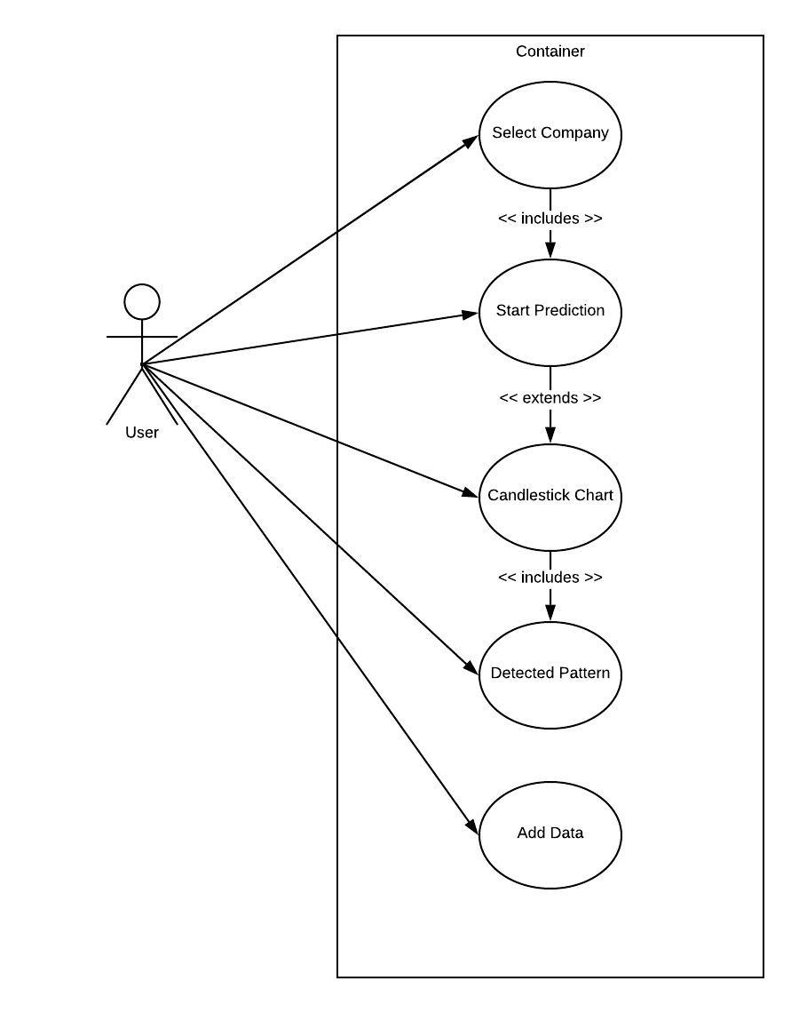

**Flow-Chart Diagram**

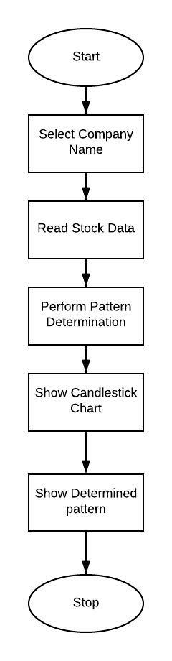

**Implemented Modules**

**Candlestick Chart:**

JFreeChart is an open-source java chart library is used to make a variety of charts, It supports many formats including Java FX, and Java Swing. CandleStick Chart renderer was used to make Candlestick Chart.

**8. Proposed Model / Framework**

The project uses an Expert system, which has a complete set of rules which make the expert system works and make inferences. The project draws candlestick charts of the data.

As defined by Wikipedia “A candlestick chart is a style of financial chart used to describe price movements of a security, derivative, or currency.”  
  
The model represents the data in the form of candlestick charts and then uses the Expert System designed in CLIPS to identify well-defined patterns in the data which are used by experts to predict stock market. There are some well defined patterns of candlestick charts which have been studied in depth and whose future behavior can be reasonably   
Predicted.

Pattern Matching is run on the candlestick charts so as to find these well defined patterns such as Three Line Strike, Two Black Gapping, Three Black Crows, Evening Star, The Hammer, The Morning Star and so on.

The Knowledge base and the inference engine have been written in CLIPS and the GUI along with the data read/write interface is in Java. Java is the basic coding environment for the GUI part of the project. CLIPS Java Native interface, a Java Native interface which is used to connect CLIPS to Java has been used.

The model first reads the dataset which is stored as a csv file and contains stock market data for Companies over an interval of time (Data collected from Yahoo Finance). Then the data is represented using a candlestick chart. Next, the Expert System searches for patterns in the candlestick chart made. After the closest match is found and the future of stocks predicted, the model informs the user if it is the right time to sell/buy stocks and other such information.

**Features:**

1. **Analyse the past Stock data :**

The project being an expert system, analyses the past data and tells which pattern it is following. Candlestick charts for real Stock Market data have a few common patterns which have been noticed and named by the experts. These patterns in our current data is what helps us analyse them.

1. **Predict performance of Stock in future :**

The model predicts the performance of the stock in the future. It is also done with the help of the expert system which has dozens of patterns which contains information about how the future performance is most likely to be. So we predict the pattern and hence can predict the future stocks.

1. **Predict Right Time to invest / Sell Stock :**

The project tells about the right time to invest/ sell stock. The expert system can analyse the stock market data and tell when it will be the right time to invest and when to sell stock.

1. **Advise whether to Buy / Sell stock presently :**

The project also tells whether the user, right now, should invest in a stock or sell his shares using the knowledge it has from the patterns detected in the past data. This is the most prominent feature of the Stock Market Expert System, it can predict the stocks from the past stock patterns and tell whether to sell or buy stocks currently.

1. **Draw Candlestick Chart to represent data :**

The projects represents the data (stored in a csv file or in a table with 4 fields) which is very difficult to read and analyse into a candlestick chart, which makes it much easier to observe even by a non-expert of stocks and for experts it makes the data easier to analyse.

1. **Match Candlestick chart to find the template patterns used by Experts :**

The model matches the candlestick charts made by the data to some well defined patterns of candlestick charts which have been studied in depth and whose future behavior can be reasonably predicted.

Pattern Matching is run on the candlestick charts so as to find these well defined patterns such as Three Line Strike, Two Black Gapping, Three Black Crows, Evening Star, The Hammer, The Morning Star and so on.

# **9. RESULTS**

Proposed framework is knowledge based expert system and doesn't rely upon information. With the assistance of visual supervisor instrument even a typical client can likewise enter productive candlestick design as it shows up on outline. It is conceivable to draw designs on candlestick outline, along these lines check the information granted in the framework. It is conceivable to include new design in the framework with the assistance of example proofreader which makes it extendable.

We are basically using an expert system to predict stock market by generating different candlestick patterns and predicting whether to sell ,buy or hold the given stock at the present time, data is being given for different companies for a given time stamp.We are generating the given 6 candlestick patterns -:

* Bearish Separating Lines
* Bearish Shooting Star
* Black Spinning Top
* Bullish Separating Lines
* Bullish Shooting Star
* White Spinning Top

# **10. CONCLUSION**

On account of advances in the field of Data Mining and AI, soft computing based programmed examination of data has got an impressive consideration from examinee network. Mechanized examination of stock data is one of such issues which are broadly examined by numerous specialists. This examination identifies capacity of Candlestick examination as one of the helpful specialized pointers for transient expectation of stock cost vacillations, and market timing.

Here we have taken 6 candlestick patterns .We could increase our knowledge based by increasing number of candlestick patterns,which will predict much better as accuracy will increase.

We could increase data by increasing number of companies ,this will also increase our model accuracy. Also by increasing time stamp for each company could give us more information regarding the given data.

# **11. REFERENCES**

# Sahaj Singh Maini ,Govinda.K, *“ Stock market prediction using data mining techniques*.” ( Available at : <https://ieeexplore.ieee.org/document/8389253> ), 2017 International Conference on Intelligent Sustainable Systems (ICISS), 7-8 Dec. 2017, INSPEC Accession Number: 17858480

# Ishita Parmar ,Navanshu Agarwal ,Sheirsh Saxena,Ridam Arora,Shikhin Gupta,Himanshu Dhiman ,Lokesh Chouhan “*Stock Market Prediction Using Machine Learning*” (Available at :<https://ieeexplore.ieee.org/document/8703332>), 2018 First International Conference on Secure Cyber Computing and Communication(ICSCC)

1. Jan Ivar Larsen,”*Predicting Stock Prices Using Technical Analysis and Machine Learning*” (Available at : <https://core.ac.uk/download/pdf/52104888.pdf>),Thesis for June 2010 Helge Langseth, IDI Master of Science in Computer Science Submission date:Supervisor: Norwegian University of Science and TechnologyDepartment of Computer and Information Science
2. Pawan Kumbhare,Rohit Makhilja, Hitesh Raichandan,”Stock Market prediction” (Available at : <http://www.cse.scu.edu/~mwang2/projects/Predict_stockMarket_16w.pdf>)
3. CandleStick Chart (Available at : [https://en.wikipedia.org › wiki › Candlestick_pattern](https://en.wikipedia.org/wiki/Candlestick_pattern))
4. How to use single candlestick chart pattern for trading.(Available at : <https://www.moneycontrol.com/news/business/markets/technical-classroom-how-to-use-single-candlestick-chart-pattern-for-trading-3266531.html>)
5. Expert system for predicting stock market timing using a candlestick chart .K.H. Lee, G.S. Jo* “Expert system for predicting stock market timing using a candlestick chart “ (Available at: <https://pdfslide.net/documents/expert-system-for-predicting-stock-market-timing-using-a-candlestick-chart.html> ), Expert Systems with Applications 16.